**Connect to the Store Sales Data and do the following: -**

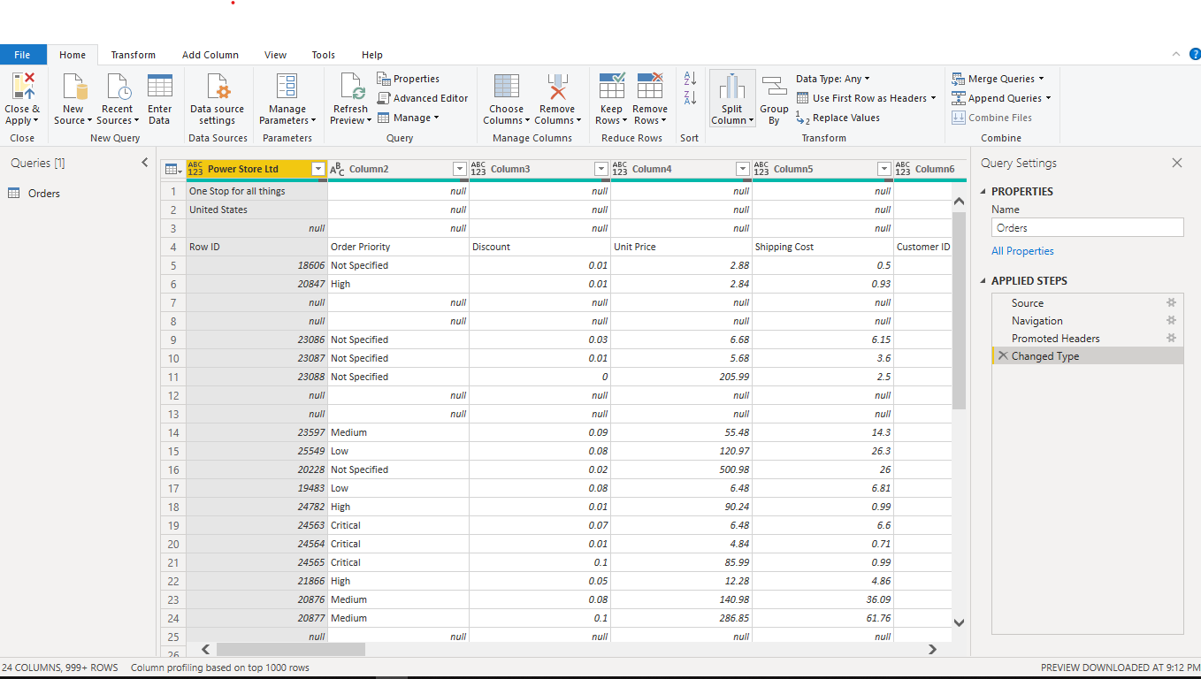

**Remove all the blank rows**

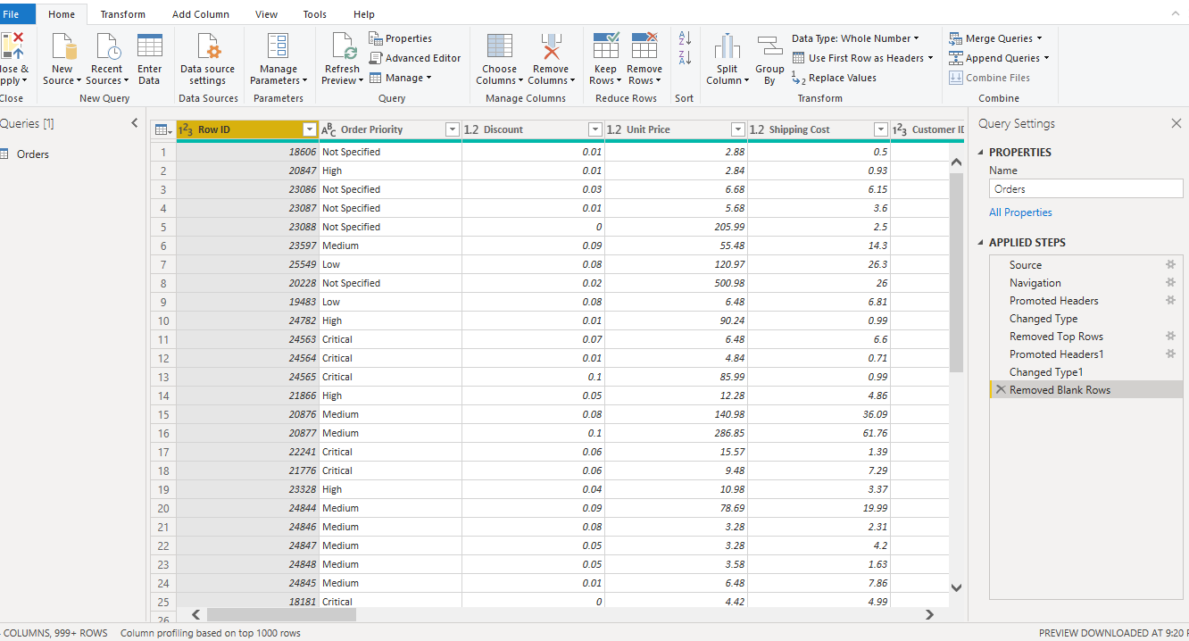

**Update the column header if they are not updated**

**🡪 Updated the column**

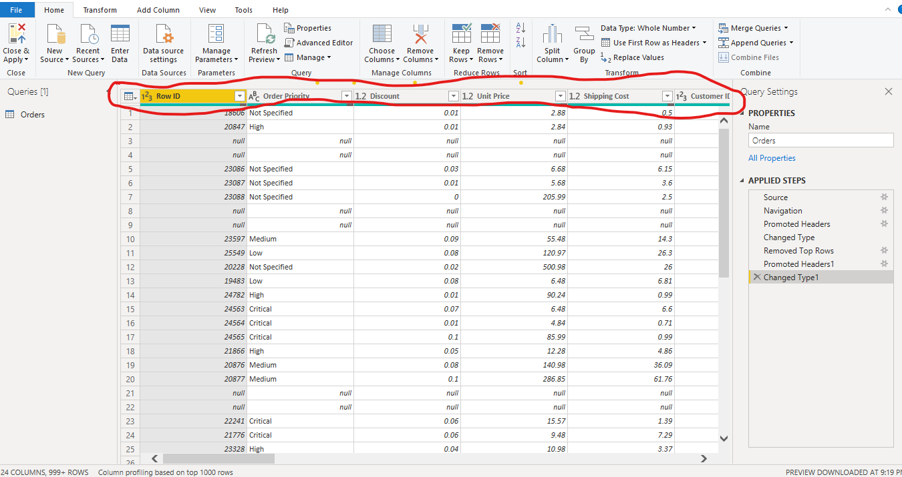

**Create a text table and show the sales in terms of**

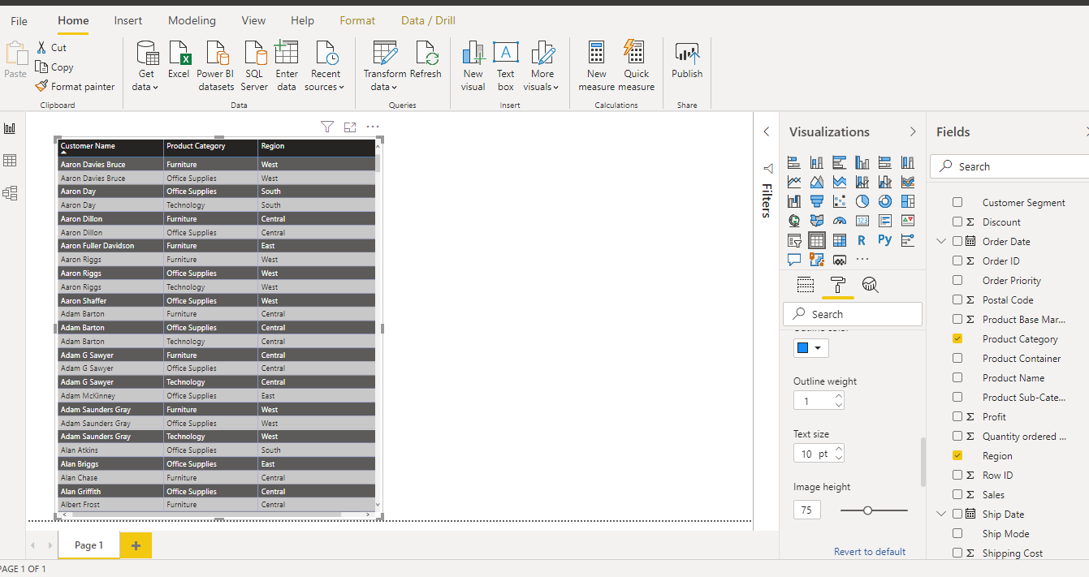

**Create a line and Clustered Column Chart showing the Sales and Discount as per the State or Province**

🡪 **Format the bars and line with different colors**

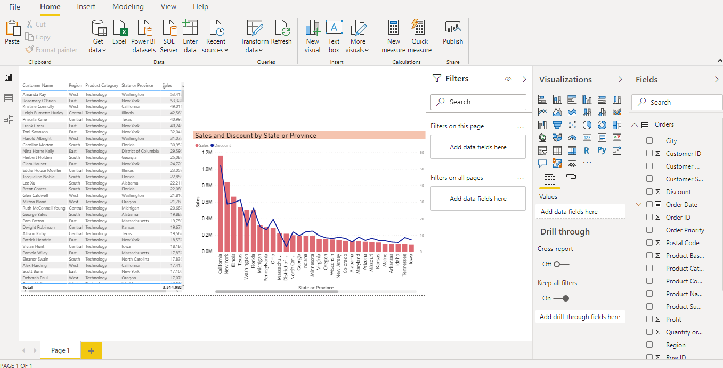

**Which state has the highest sales in terms Technology**

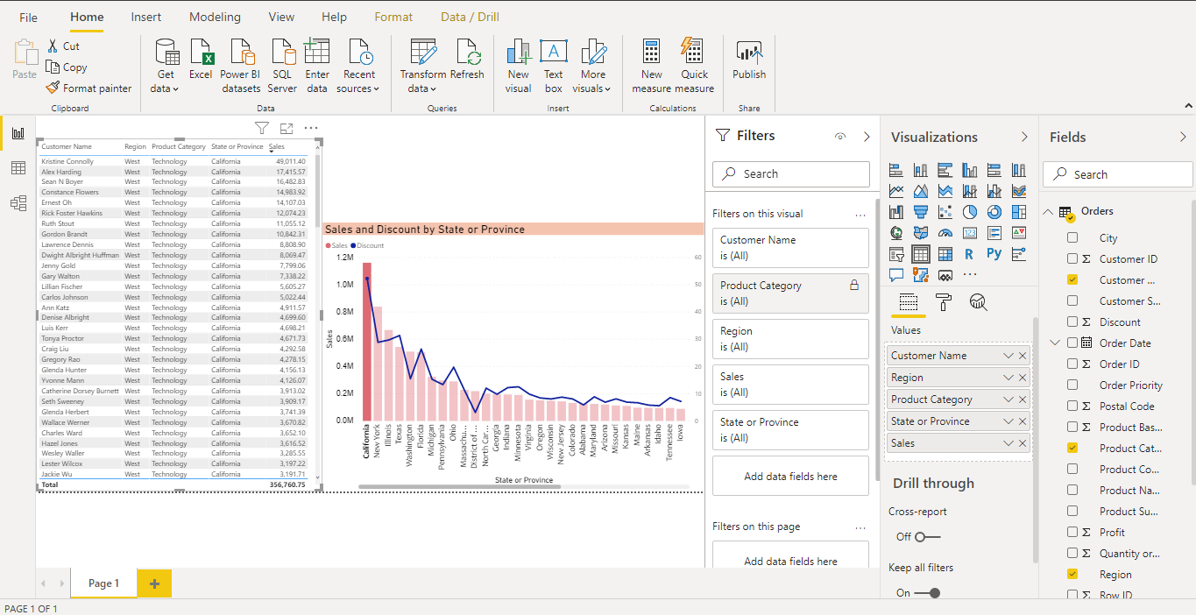

**Create a** *Donut Chart* **showing sales in terms of Product category**

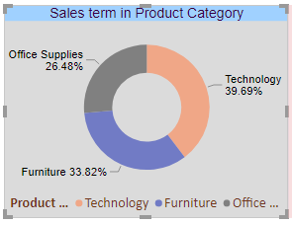

**Create a** *Slicer* **and show the regions in dropdown. See how all the visuals mentioned above behaving when a particular region is selected.**

**--🡪 Central**

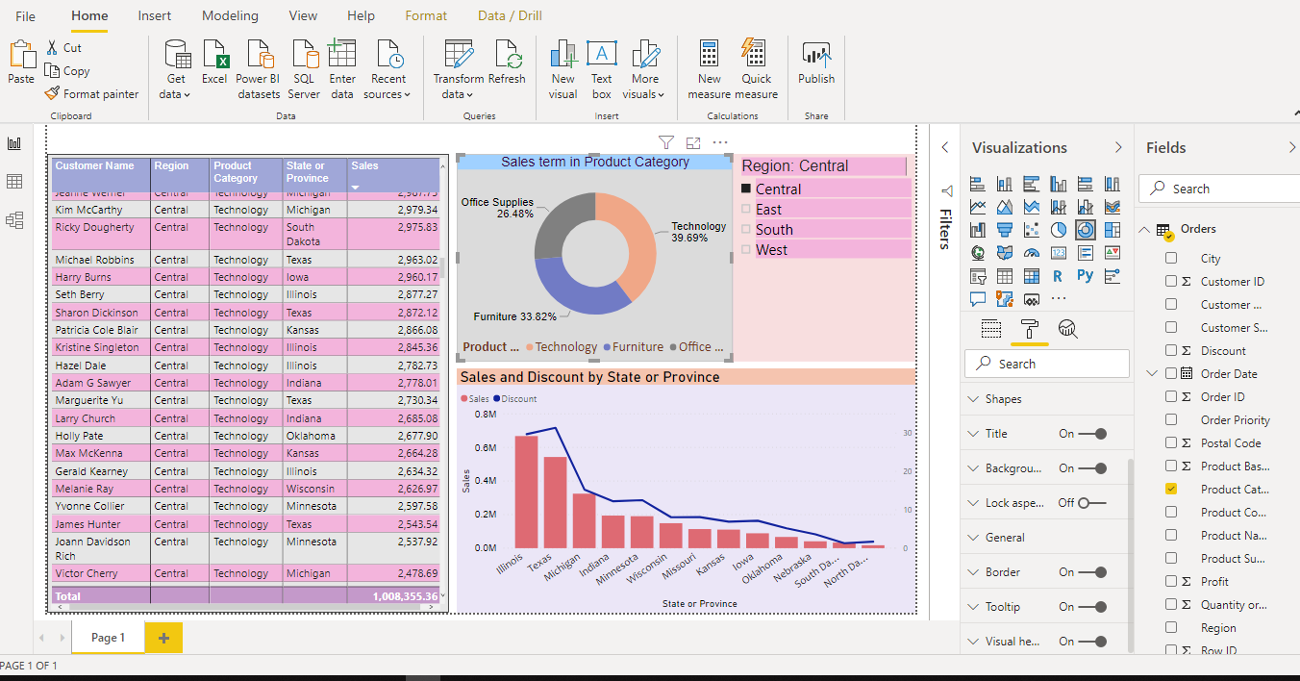

🡪 **East**

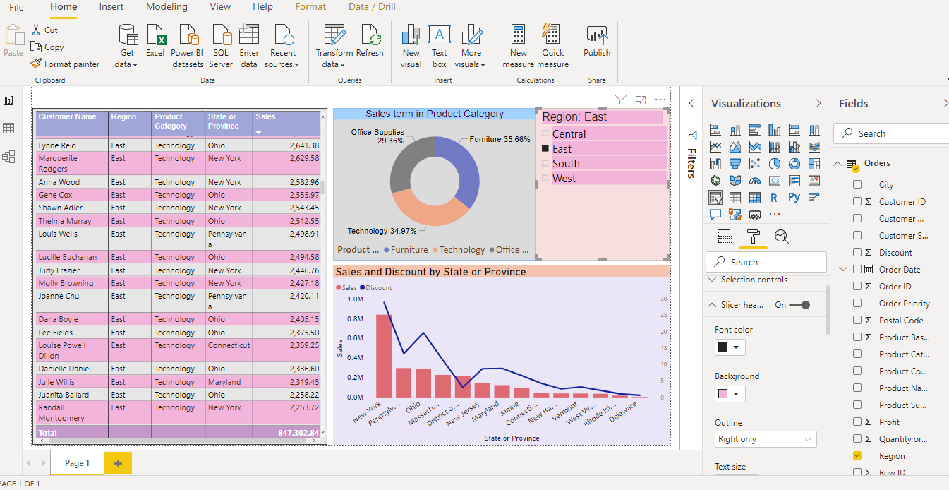

**🡪 South**

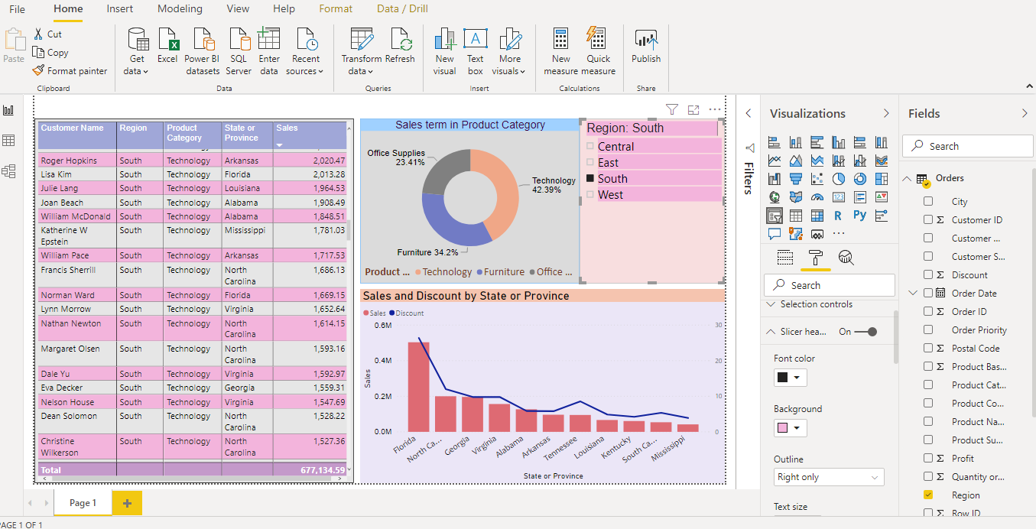

**🡪 West**

